VBCS Training Lab 03   
UI Design – Working with Related Data

# Introduction

In this hands-on-lab, we look at how to work with data that comes from different sources in the same UI. Specifically, we will set the Class list to pull in data from its related Course record. We’ll also set the Edit Class page to show the list of available courses in a drop-down.

# 

# Hands on Lab Instructions

## Setting up the Application

1. In the list of apps, click Import.
2. Drag and drop VBCS-Lab03.zip into the dialog box.
3. Append your username to the Application ID to make it unique – i.e. VBCSLab03-*MyName*
4. Click Finish

## Add the Course Title to the List of Classes

### Fetching the Course Name in the REST Call

1. Open the start page.
2. Click the Variables tab in the left of the page editor to display the variables.
3. Select the classListServiceDataProvider variable.
4. In the Properties Inspector, click the ../../Screenshots/Screen%20Shot%202018-02-16%20at%202.53.06%20PM.pngbutton for Input Parameters.  
   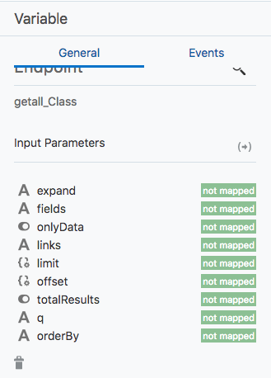
5. Select uriParameters > fields and enter 'name,startTime,endTime,daysOffered;courseObject:id,title' in the Expression field. The wizard will automatically surround it with {{ }}.
6. To make your REST output a bit easier to deal with, select onlyData and enter true.  
   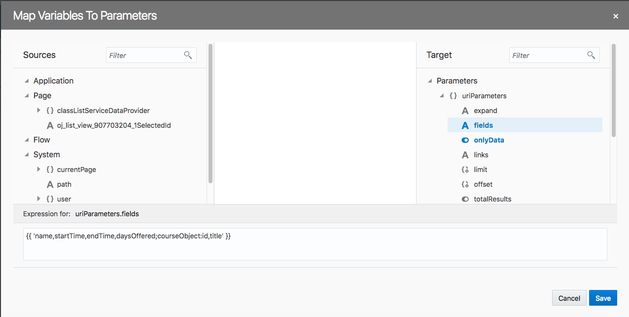
7. Click Save. If you reload the page now and look in your Chrome Developer Tools, you’ll see the Course Name is being inlined as an array with one item.  
   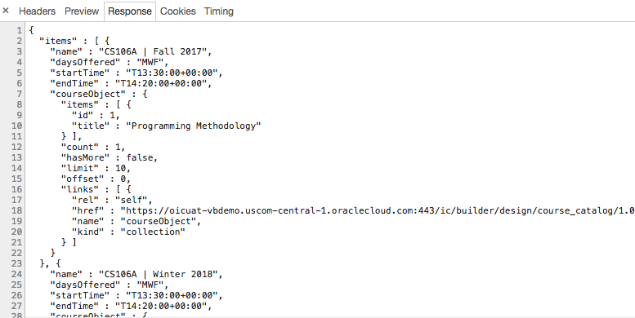

### Updating the Type to Include the Course Info

1. Go to Web Applications panel and double-click webapp1 > webapp1.
2. Click Variables > Types.  
   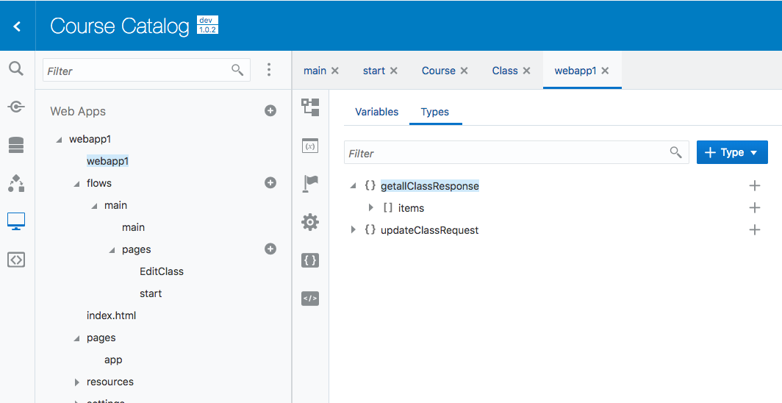
3. Click the ../../Screenshots/Screen%20Shot%202018-02-16%20at%203.04.56%20PM.pngsign for getallClassResponse > items.
4. Add an Object called courseObject.  
   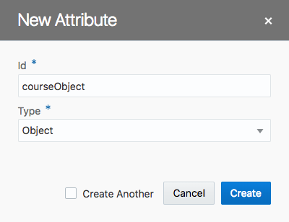
5. Click the ../../Screenshots/Screen%20Shot%202018-02-16%20at%203.04.56%20PM.pngsign for courseObject and create an Array of Objects called items.  
   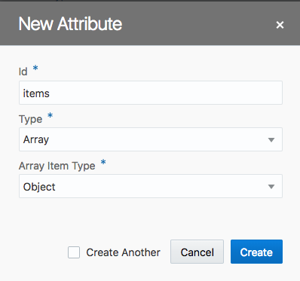
6. Click the ../../Screenshots/Screen%20Shot%202018-02-16%20at%203.04.56%20PM.pngsign for items and create a Number called id and a String called title. Your completed type should look like this:  
   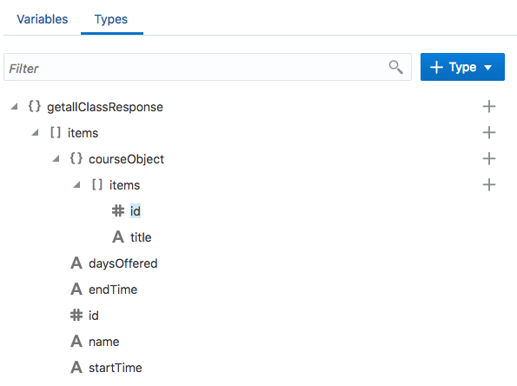

### Add the Course Title to the List

1. Go back to the start page in the designer.
2. Drop a Paragraph between the Class Title and the Class Times in the list.
3. Select the Paragraph. In the Properties Inspector, enter [[$current.data.courseObject.items[0].title]] in the Text field. The List updates with the Course Title.  
   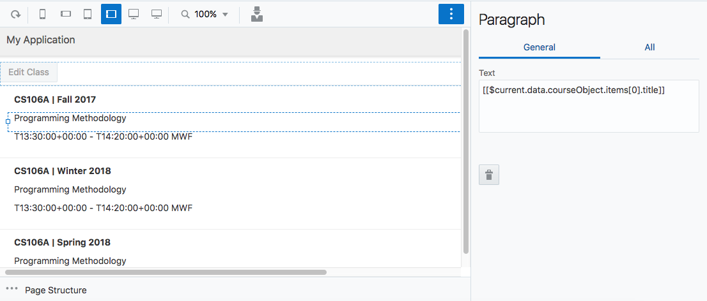

## Adding a Course Drop-Down to the Edit Page

### Adding the Select Component to the Page

1. Open the EditClass page.
2. Drop a Select One component between the Name and Start Time fields. Change the Label Hint to Course.

### Creating a Page Variable to Hold the Course Titles

1. Open the Variables tab for the page. Create a new Array of Objects called courseOptions.
2. Add a Number field called id and a String field called value. **You have to name these fields id and value!**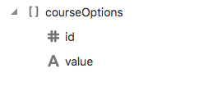

### Creating an Action Chain to Populate the Course Names

1. Open the Actions tab. Create a new action chain called populateCourseOptions
2. Double-click populateCourseOptions to open the Action Chain Editor.
3. Drag a Call Rest Endpoint action under Start. Click Select Endpoint and choose Business Objects > Course > getall_Course.  
   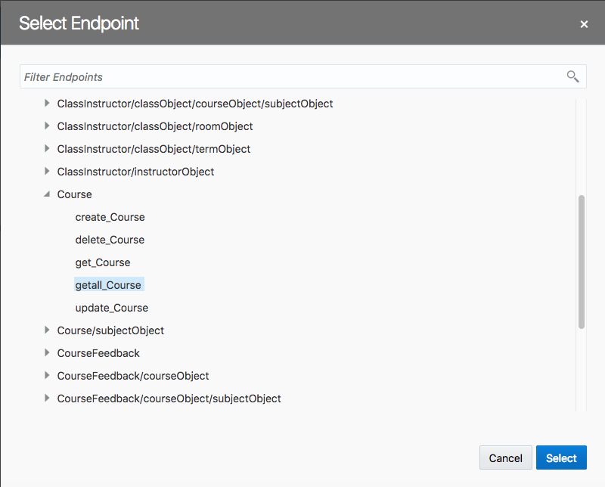
4. Drag an Assign Variables action below the Call Rest Endpoint action. Name it AssignCourses
5. Click the ../../Screenshots/Screen%20Shot%202018-02-16%20at%203.29.43%20PM.png button next to Variables
6. From the Sources panel on the left, select Chain > Results > callRestEndpoint1 > body > items and drag it over to Targets > courseOptions on the right.
7. Do the same with items > id to courseOptions > id
8. Do the same with items > title to courseOptions > value  
   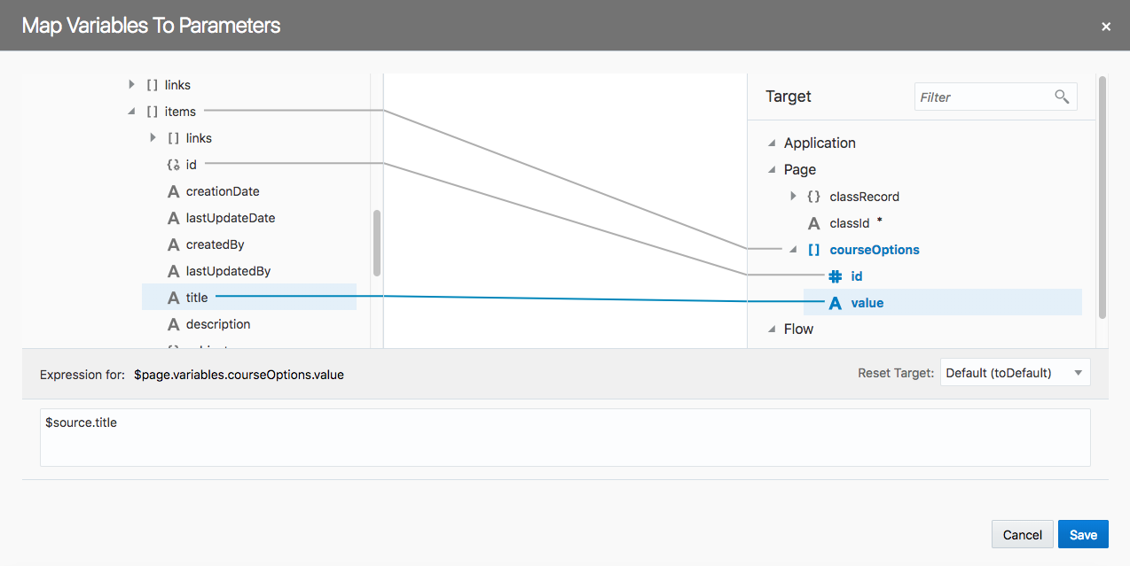
9. Click Save. Close the Action Chain Editor tab.

### Adding an Event to Load the Course Names on Page Enter

1. Select the EditClass page and click the Settings button ../../Screenshots/Screen%20Shot%202018-02-16%20at%203.34.05%20PM.png
2. At the bottom of the list of Events. Click New Event. Choose the vbEnter event and click Select. Then choose the populateCountryOptions and click Select.  
   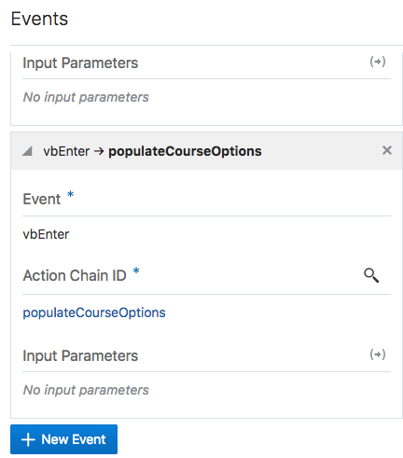

### Adding the Course Property to the updateClassRequest Type

1. Go back to the webapp1 tab in the editor. Click the Variables button and then the Types tab.
2. Add a Number field called course to the updateClassRequest type

### Binding the Select Component

1. Go back to the EditClass tab and open the page designer.
2. Select the Course dropdown.
3. In the Properties Inspector, click the Data tab and use the drop downs to set Value to {{ $page.variables.classRecord.course }} and Options to {{ $page.variables.courseOptions }}.  
   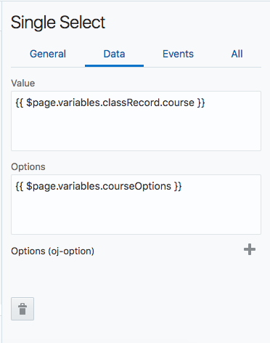
4. The drop-down is now populated.  
   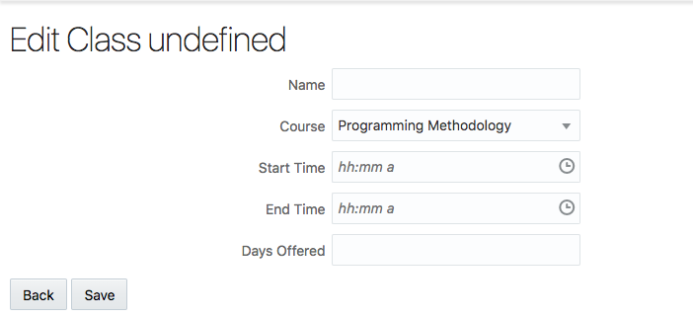

# Conclusion

Oracle Visual Builder Cloud Service is one of the fastest ways to develop and deploy an application to nearly any platform. Whether you are a seasoned application developer or have no technical background at all, VBCS gives you the ability to work with and share data more efficiently than ever before.

Be sure to visit the Oracle VBCS web site to get the latest details about this revolutionary application development tool and many other Oracle Cloud offerings.

<https://cloud.oracle.com/visual-builder>